ABSTRACT

Eye diseases have been a significant health concern throughout history, with conditions such as Age-related Macular Degeneration (AMD) increasingly recognized as main causes of the vision impairment worldwide. Traditionally, the assessment of retinal conditions relied heavily on manual evaluations of Optical Coherence Tomography (OCT) images, which, while effective, are often time-consuming and require specialized expertise.

The Categorizing of retinal diseases utilizing OCT images has garnered considerable interest in the domain of computational medical imaging. This project introduces a deep learning methodology for the automated classification of OCT images via a custom Convolution Neural Network (CNN) in conjunction with recognized transfer learning models. Deep learning methodologies are favored for their exceptional accuracy and performance; however, they frequently necessitate substantial computational resources and time for training. We employ MobileNet, ResNet50, GoogleNet, and DenseNet for feature extraction and comparison analysis.

The models are trained and refined on an OCT dataset utilizing various hyperparameter settings, such as learning rate, epoch count and optimizing techniques to get maximal accuracy. Upon concluding our study, we evaluate the performance of these models and ascertain the optimal design based on accuracy and additional assessment criteria. Our methodology illustrates the capability of deep learning in the automated classification of OCT images, providing enhanced diagnostic support for the identification of retinal diseases.

One of the strongest components of this project is the comparison of multiple model classification performance metrics evalution, including accuracy, precision, recall, F1-score, and confusion matrices. By comparing different architectures in a structured way, we determine the best performing and accurate deep learning model for retinal detection of OCT images. The outcome of this research contributes to the literature in AI-assisted ophthalmology, offering a cost-efficient and scalable solution for early detection and screening of retinal disease. This project supports the Sustainable Development Goal (SDG) 3: Good Health and Well-being goal by promoting the utilization of new and advanced technology in healthcare in order to facilitate timely diagnosis, support patient outcomes, and improve the quality of healthcare services and practice. Additionally, with the automation of deep learning AMD detection, this project can support reducing preventable blindness through early detection of AMD and contribute to sustainable health practices.

TABLE OF CONTENTS

CHAPTER NO. TITLE PAGE NO.
ABSTRACT iv
LIST OF TABLES v
LIST OF FIGURES vi
LIST OF ABBREVIATIONS vii

1 INTRODUCTION 1
1.1 BACKGROUND 1
2 LITERATURE REVIEW 3
2.1 OVERVIEW OF OCT IMAGING 3
2.2 EXISTING METHODS IN IMAGE
CLASSIFICATION 4
2.3 COMPARATIVE STUDIES 5
3 RESEARCH METHODOLOGY 6
3.1 PROBLEM STATEMENT 6
3.2 SCOPE FOR STUDY 6
3.3 OBJECTIVE OF THE STUDY 7
3.4 REALISTIC CONSTRAINTS 7
3.5 ENGINERRING STANDARDS 7
4 DESIGN AND METHODOLOGY 8
4.1 THERORITICAL ANALYSIS 8
4.2 DATA COLLECTION 9
4.3 MODEL SELECTION 10
4.3.1 CNN 10
4.3.2 GoogleNet 11
4.3.3 DenseNet 11
4.3.4 ResNet50 12
4.4 SYSTEM ARCHITECHURE 12
4.5 TRAINING, TESTING AND VALIDATION 13
4.6 EVALUTION METRICS 14
5 RESULTS AND DISCUSSION 17
5.1 EXPERIMENTAL RESULTS 17
5.2 MODEL PERFORMANCE 17
5.2.1 Accuracy 18
5.2.2 Comparison with other predictive models 18
5.3 ANALYSIS OF RESULTS 22
5.4 SUGGESTIONS AND RECOMMENDATIONS 27
6 CONCLUSION AND FUTURE WORK 29
6.1 SUMMARY 29
6.2 CONCLUSIONS 30
6.3 FUTURE ENHANCMENTS 30
REFERENCES 31
PUBLICATION DETAILS 33

LIST OF TABLES
Table 4.1 Training and Testing Model Metrics . . . . . . . . . . . . . . . . . . . . . . .14
Table 5.1 Comparison of DenseNet Model . . . . . . . . . . . . . . . . . . . . . . . . . . .19
Table 5.2 Comparison of CNN Model . . . . . . . . . . . . . . . . . . . . . . . . . . . . . . 20
Table 5.3 Comparison of ResNet50 Model . . . . . . . . . . . . . . . . . . . . . . . . . . 20
Table 5.4 Comparison of GoogleNet Model . . . . . .. . . . . . . . . . . . . . . . . . . . 20

LIST OF FIGURES

Figure 2.1 Abnormal eye . . . . . . . . . . . . . . . . . . . . . . . . . . . . . . . . . . . . . . . . . . . . . 3
Figure 2.2 Normal eye . . . . . . . . . . . . . . . . . . . . . . . . . . . . . . . . . . . . . . . . . . . . . . 3
Figure 4.1 CNN Architecture . . . . . . . . . . . . . . . . . . . . . . . . . . . . . . . . . . . . . . . . . . 10
Figure 4.2 GoogleNet Architecture . . . . . . . . . . . . . . . . . . . . . . . . . . . . . . . . . . . . . . .11
Figure 4.3 DenseNet Architecture . . . .. . . . . . . . . . . . . . . . . . . . . . . . . . . . . . . . . . .11
Figure 4.4 ResNet Architecture . . . . . . .. . . . . . . . . . . . . . . . . . . . . . . . . . . . . . . . . . .12
Figure 4.6 Project Workflow . . . . . . . . .. . . . . . . . . . . . . . . . . . . . . . . . . . . . . . . . . . .13
Figure 5.1 Model Comparison Graph . .. . . . . . . . . . . . . . . . . . . . . . . . . . . . . . . . . . .21
Figure 5.2 Model Training and Testing Accuracy . . . . . . . . . . . . . . . . . . . . . . . . . . . .21
Figure 5.3 Model Training and Testing Loss . . . . . . . . . . . . . . . . . . . . . . . . . . . . . . . 22
Figure 5.4 Confusion Matrix . . . . . . . . . . . . . . . . . . . . . . . . . . . . . . . . . . . . . . .. . . . . 24
Figure 5.5 ROC Curve . . . . . . . . . . . . . . . . . . . . . . . . . . . . . . . . . . . . . . . . . . . . . . . .24
Figure 5.6 Accuracy Curve . . . . . . . . . . . . . . . . . . . . . . . . . . . . . . . . . . . . . . . . . . . .25
Figure 5.7 Loss Curve . . . . . . . . . . . . . . . . . . . . . . . . . . . . . . . . . . . . . . . . . . . . . . . . 25
Figure 5.8 Web Application Desktop Version . . . . . . . . . . . . . . . . . . . . . . . . . . . . . . . 27
Figure 5.9 Web Application Output Image . . . . . . . . . . . . . . . . . . . . . . . . . . . . . . . . . 27

ABBREVIATIONS
AMD - Age-related Macular Degeneration
OCT – Optical Coherence Tomography
CNN- Convolution Neural Network
ResNet50 – Residual Network
ROC/AUC - Receiver Operating Characteristic/Area Under Curve
DME – Diabetic Macular Edema
CNV – Choroidal neovascularization
RNN – Recurrent Neural Network

CHAPTER 1

INTRODUCTION

  - Background
The development of medical imaging has revolutionized diagnostics, particularly in ophthalmology. Initially, retinal conditions were diagnosed through direct observation, which was limited by the quality and depth of the physician's view. The introduction of OCT in the early 1990s marked a significant advancement, enabling high-resolution cross-sectional imaging of retinal layers. This innovation provided unprecedented detail, allowing clinicians to detect and monitor diseases like age-related macular degeneration (AMD) with greater accuracy.
Eye diseases have been a severe public health issue for decades, affecting millions of individuals globally. Of these, Age-related macular degeneration (AMD) has been one of the main source of vision loss and blindness, primarily among the elderly. Although these methods tells that all the expert assessments are extremely specific, consuming, labor-intensive, and prone to inter-observer variability, leading to preventable delay in diagnosis and therapy.
With the rapid advancement of artificial intelligence (AI) and deep learning, computational approaches have revolutionized the field of medical imaging to offer computerized solutions for disease detection and classification. Convolutional Neural Networks (CNNs) have proved phenomenal in handling intricate medical image data, feature hierarchies, and high-precision classification. Deep learning approaches have gained widespread use in the detection of retinal disease, where they outperform traditional machine learning models significantly by reducing handcrafted feature extraction and enabling end-to-end learning from raw images.
This work introduces a deep learning framework for the automatic OCT image classification, using a customized CNN model and well-known transfer learning models. Transfer learning uses pre-trained models to effectively learn features and enhance the classification performance, particularly in the case of small medical image datasets. Here, we apply MobileNet, ResNet50, GoogleNet, and DenseNet as transfer learning models and compare their classification accuracy with that of a customized CNN model fine-tuned for OCT image processing. The models are trained, fine-tuned, and optimized with different hyperparameter settings, like learning rate, epochs, batch size, and optimization algorithms to achieve maximum accuracy and generalization.
A critical performance analysis of the the deep learning models is performed based on significant parameters likewise accuracy, precision, recall, F1-score, and confusion matrices. The objective is to determine the most effective and efficient deep learning model for retinal disease classification from OCT images. By comparing the strengths and weaknesses of each approach in depth, this study enables the development of AI-based ophthalmic diagnosis.
By integrating state-of-the-art deep learning models in the diagnosis of retinal disease, this work aims to bridge the gap between traditional manual assessment and modern automated methods. The result of this project not only demonstrate how much effective the AI-based classification is but also show its promise for clinical application across the board. With more refinement and real-world validation, deep learning approaches can significantly enhance the early diagnosis of retinal disease, allowing for timely medical intervention and precluding the possibility of vision loss. As AI continues to evolve, its application in ophthalmology is likely to make diagnosis simpler, improve the accessibility of healthcare, and contribute to the betterment of patient outcomes globally.

CHAPTER 2
LITERATURE SURVEY
2.1 Overview of OCT Imaging
Optical Coherence Tomography (OCT) has revolutionised ocular imaging since its introduction, offering non-invasive, high-resolution, the cross-sectional images of the retina. OCT employs light waves to get intricate images of retinal layers, facilitating the early identification and surveillance of disorders such as AMD.
Early OCT systems provided a novel way to visualize internal structures without invasive techniques, quickly gaining popularity in ophthalmology for diagnosing and keeping an eye on retinal diseases like age-related macular degeneration (AMD), diabetic retinopathy, and glaucoma. Before OCT, ophthalmic imaging primarily relied on techniques such as fundus photography and fluorescein angiography, which provided only two-dimensional views and less detail.
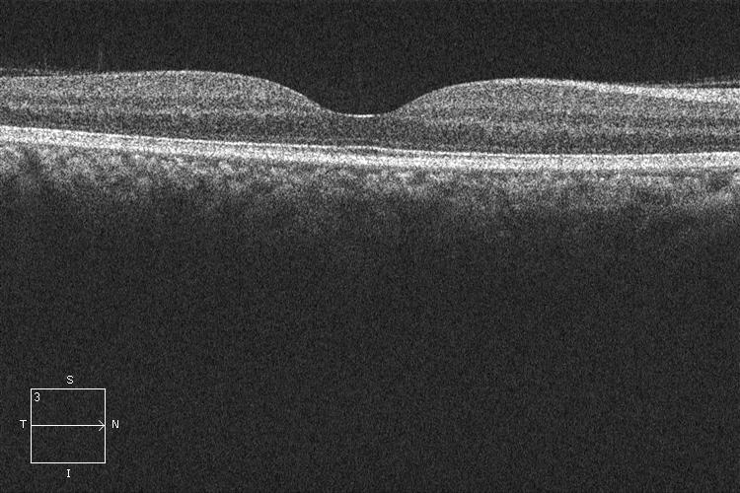
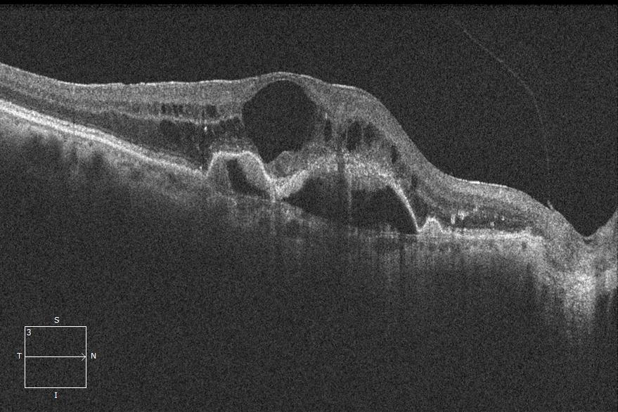
OCT’s importance has only grown in present years with the merging of artificial intelligence and machine learning. These methods have enhanced OCT’s diagnostic capabilities by automating image analysis, assisting in the rapid identification of retinal abnormalities. Automated OCT classification systems are now under exploration for their potential to reduce the workload of clinicians and to provide early, accurate diagnoses in underserved areas with limited access to specialist care.
Fig 2.1. Abnormal Eye Fig 2.2. Normal Eye

2.2 Existing Methods in Image classification
Before the advent of Optical Coherence Tomography (OCT), ophthalmologists primarily relied on other imaging and diagnostic techniques to assess retinal health. Key early methods included:
- Fundus Photography: Fundus cameras captured images of the retina and were widely used for diagnosing conditions like diabetic retinopathy and glaucoma. However, fundus photography only provided a two-dimensional view, limiting the detail and depth of information.
- Fluorescein Angiography: This technique involved injecting a fluorescent dye into the bloodstream to highlight retinal blood vessels, helping clinicians visualize blood flow and detect abnormalities. While effective, this method was invasive and posed risks, including potential allergic reactions to the dye.
- Ultrasound Imaging: Ultrasound B-scans were used to validate cross-sectional images of the eye's internal structures. Although non-invasive, ultrasound imaging had limited resolution, making it challenging to diagnose fine retinal structures with accuracy.
These early methods provided valuable information but lacked the high-resolution, non-invasive imaging that OCT would eventually deliver. The limited detail and invasiveness of these techniques underscored the need for a more refined imaging tool.
- Spectral-Domain OCT (SD-OCT) and Swept-Source OCT: As OCT technology evolved, new generations like SD-OCT and Swept-Source OCT emerged, offering greater resolution, faster imaging speeds, and deeper retinal penetration.
- Convolutional Neural Networks (CNNs): In recent years, CNNs have become the cornerstone of image classification for OCT. CNNs automatically learn complex features within images, enabling accurate classification of retinal conditions from OCT scans. Networks like ResNet, VGGNet, and Inception are widely used, each architecture offering unique strengths in capturing retinal details.
- Transfer Learning fosr Limited Data: Since labelled OCT data can be scarce, transfer learning has become popular in OCT image classification. By fine-tuning models pre-trained on large datasets, clinicians achieve high accuracy with smaller datasets. This approach is effective in retinal image classification tasks and helps optimize resources in medical imaging.
2.3 Comparative studies
Many research studies have utilized retinal imaging, i.e. fundus and OCT images, for the classification of diseases with each making original contributions to the advancement of computerized diseases diagnosis in ophthalmology.
Dong et al. (2017) [1] implemented a deep learning architecture for classifying cataract fundus images showing the potential of CNNs in processing medical imaging data. While not specifically focusing on OCT, their model performance highlighted how deep learning can effectively distinguish between retinal and normal disease conditions.
On the other hand, Kadry et al. (2022) [3] focused on AMD by employing OCT images and a pre-trained deep learning model. Their method utilized the transfer learning, which demonstrated enhanced accuracy as a result of utilizing pre-trained networks, especially efficient on comparatively smaller OCT datasets.
Zhang et al. (2018) [5] transferred deep learning to screening of Retinopathy of Prematurity (ROP) from wide-angle retinal images. Their system showed deep neural networks' generalizability to various retinal conditions and the model's versatility with imaging modalities.
Raghu Raj et al. (2007) [2] proposed algorithmic approaches toward early detection of disease by analyzing retinal images. Their classical machine learning approaches provide an interesting contrast to modern deep learning based approaches, acting as a historical marker for comparing performance based on feature extraction.

CHAPTER 3
RESEARCH METHODOLOGY
3.1 Problem Statement
The primary aim is to develop an effective and precise system for classifying OCT images under different categories. Manual diagnosis is not reliable and time-consuming, leading to delayed treatment. Using deep learning models like CNNs, MobileNet, ResNet50, GoogleNet, and DenseNet, this research aims to make the classification automated, providing a reliable tool to assist healthcare professionals in early and precise detection of AMD.
3.2 Scope of Study
This study examines the application of deep learning models having models like Convolutional Neural Networks (CNNs) and transfer learning techniques to classify OCT images into different categories. The key components are:
- Data Collection and Preprocessing: Collection and also the pre-processing of the dataset the images, ensure the quality and consistency of the image for effective training of a model.
- Unbalanced vs. Balanced Data Testing: Comparison of model performance on data with different AMD-to-healthy image ratios to check the impact of data distribution.
- Model Training and Optimization: Employing CNN-based models such as MobileNet, ResNet50, GoogleNet, and DenseNet, hyperparameter searching to improve the efficiency of the classification.
- Performance Measurement: Evaluating models based on accuracy, precision, recall, and F1-score to identify the best and most reliable method.
- Possible Clinical Applications: Describing the possible advantages of applying the proposed system in medical diagnosis to allow medical professionals to achieve early AMD detection.
This study will form the basis of computer-aided accurate and effective OCT image classification for improved treatment and management of retinal pathology.
3.3 Objective of the Study
- To turn OCT pictures into four groups automatically: Normal, AMD (Age-related Macular Degeneration), DME (Diabetic Macular Oedema), and CNV (Choroidal Neovascularisation).
- To use deep learning models, like a special Convolutional Neural Network (CNN), and transfer learning models, like MobileNet, ResNet50, GoogleNet, and DenseNet, and check how well they work.
- To make an easy-to-use website with trained deep learning models that lets users share OCT images and get automatic classification results in real time.
3.4 Realistic Constraints
- The project requires a significant quantity of high-quality OCT pictures for training and testing. Limited access to huge and diverse datasets may impede the model's generalisability.
- Training machine learning models, particularly those with huge datasets, can consume a lot of memory, storage, and computing power. Limited access to high-performance computing resources may impair model training speed and efficiency.
- Because of the limited time available for data collection, preprocessing, model training, and evaluation, the project may need to prioritise some components, perhaps leaving less time for fine-tuning or investigating other models.
These limits are critical to consider while designing the research and evaluating its outcomes, ensuring that the study is practical and applicable within real-world constraints.
3.5 Engineering Standards
- IEEE Std 11073-2019: Health informatic—device interoperability— Part 20701: Point-of-care medical device communication— OCT device specialization.
- ASTM E2526-16: Standard guide for OCT imaging of the eye.
- ISO 10993-1:2018: Medical evaluation of medical devices: evaluation and testing within a risk management process
CHAPTER 4
DESIGN METHODOLOGY
4.1 Theoretical Analysis
The theoretical foundation of this study involves understanding the principles of OCT imaging, machine learning, and classification algorithms. OCT imaging is a technique widely used in ophthalmology to capture highly contrast images of the retina. The classification task involves applying machine learning models to distinguish between healthy and AMD-affected eyes based on OCT images. In this context, the theoretical analysis focuses on:
OCT images are produced by directing light waves through the eye and recording the backscattered light from the retinal layers. These images include anatomical features essential for identifying retinal conditions like Age-related Macular Degeneration (AMD). The images may, however, contain noise, inconsistencies, or artefacts that can impair the efficacy of image classification algorithms. Essential characteristics derived from OCT images often encompass:
- Retinal Thickness: The measurement of the retina's thickness in particular layers, which may signify age-related macular degeneration (AMD).
- Layer segmentation: Distinct retinal layers offer critical indicators for differentiating between healthy and AMD-affected tissue.
- Texture and Pattern Features: These may encompass the optical characteristics of the retina, such as reflectivity, which could be influenced by disease.
This work is based on deep learning, namely Convolutional Neural Networks (CNNs) and transfer learning for classification Optical Coherence Tomography (OCT) images. Key theoretical concepts are:
Optical Coherence Tomography (OCT) Imaging:
  - Non-invasive imaging approach for obtaining high- resolution transverse images of (retina).
  - It is an integral component of Retinal disease diagnosis such as AMD, Diabetic Macular Edema (DME) and Choroidal Neovascularization.
Deep Learning for Image Classification:
  - Deep learning-based models specifically CNNs are designed for automatic feature extraction this makes them very well-suited for medical image classification.
  - CNNs consist of various layers (convolutional, pooling and fully connected layers) that depict image learning with spatial intuition on features.
Transfer Learning Models:
- Pre-trained models like MobileNet, ResNet50, GoogleNet and DenseNet are adopted to boost classification performance and ease the training.
- These models are trained on huge scale image datasets and can be fine-tuned for OCT Image classification.
Hyperparameter Optimization:
- Parameters like learning rate, batch size and epoch to make a better model behaviour.
- Okay, optimizers (Adam and also Stochastic Gradient Descent – SGD) help with convergence and training speed.
System Integration:
  - The deep learning models are integrated into a web-based application that enables real-time classification of OCT images.
  - The website allows users to upload images and receive immediate classification results, making it accessible for healthcare professionals.
4.2 Data Collection
Data collection plays a critical role in building an effective OCT image classification model. This project utilizes a dataset of 4,200 OCT images, equally split between Normal, AMD, DME, and CNV affected retinas, for training, testing and validation purposes. The data for this project has been gathered from the open source contribution that is Kaggle.

4.3 Model Selection
This work employs a mixture of a tailor-made Convolutional Neural Network (CNN) and pre-trained transfer learning models for the classification OCT images into four classes: AMD, DME, CNV, and Normal. The selecting process emphasises:
Selection Criteria: Models are assessed on their capacity to process image data, classification precision, and computational efficiency. Due to the significance of real-time or near-real-time performance in clinical environments, models with moderate computational requirements are favoured.
Selected Models: Following an evaluation of multiple classification techniques, four models were chosen:
    - Custom Convolutional Neural Network (CNN)
- Made only for classification of OCT image with different convolutional layers to learn both spatial and hierarchical features.
- This model contains your basic convolutional layers for feature classification and extraction, pooling layers for dimensionality reduction and the fully connected layers for classification.
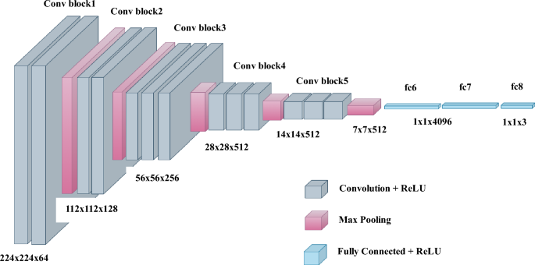
- Non-linearities are provided by activation functions, e.g ReLU to use in deeper layers and Softmax for multi-class classification.

Courtesy: https://www.nature.com/articles/s41598-023-37743-4
Fig 4.1. CNN Architecture

    - GoogleNet
- Inception architecture: the filters are of various kernel sizes and they are stacked under the inception of multiple convolutions.
- Reduces computation complexity via first performing 1x1 convolutions for down-sampling the dimensionality, and then using larger filters.
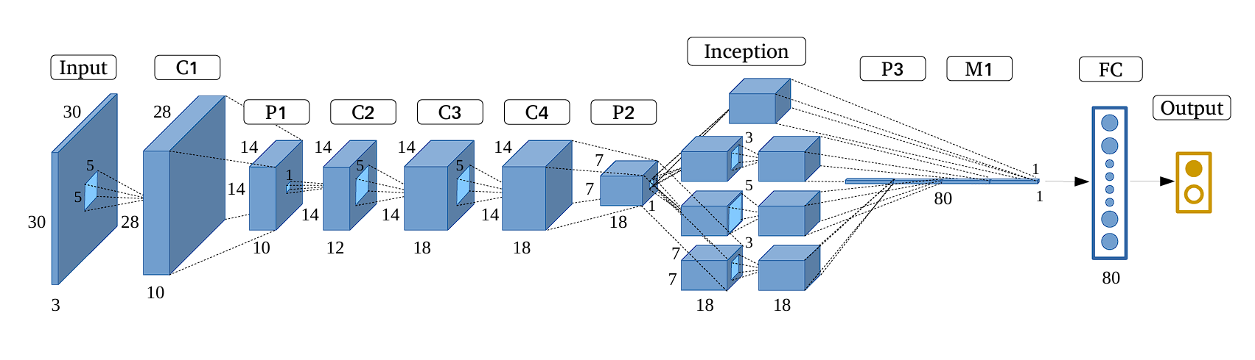
- Can be used for high accurate feature extraction & efficient in relevant image classification good at resolving fine structures of OCT images.
Courtesy: https://bmcmedimaging.biomedcentral.com/articles/10.1186/s12880-024-01394-2
Fig 4.2. GoogleNet Architecture

    - DenseNet (Densely Connected Convolutional Networks)
- Densely Connected Layers where every layer is connected to all the previous layers directly and form feature reuse along with gradient flow improvements.
- Compared to regular CNNs, it needs lower parameters and thus well in terms of memory and computation.
- It has increased propagation of features and therefore improved learning/loading accuracy in classification problems.
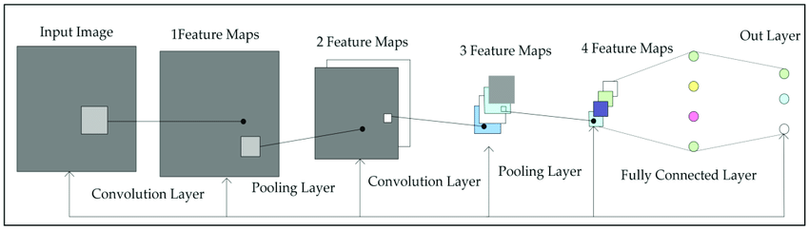

Courtesy: https://iq.opengenus.org/architecture-of-densenet121/
Fig 4.3. DenseNet Architecture
    - ResNet50
- An Example of a deep neural network with 5 layers are used to beat the diminishing gradient problem of deep networks.
- It takes advantage of residual connections (skip connections) to allow training very deep network without losing gradient information.
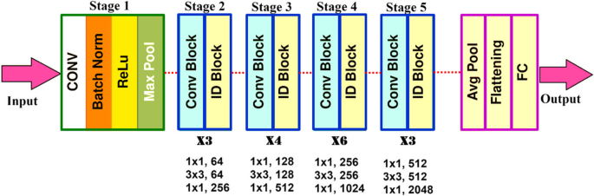
- Allows to learn complex patterns and features of OCT images and thus increases classification accuracy.

Courtesy: https://bmcmedimaging.biomedcentral.com/articles/10.1186/s12880-024-01394-2
Fig 4.4. ResNet50 Architecture

  - System Architecture
The system architecture for this OCT image classification project consists of several stages, including data gathering, preprocessing of data, model selection, training, testing, and validation. The system is made to streamline the flow from raw OCT images to the final classification results, ensuring efficient data handling and model processing. The main components of the architecture include:
- Input Data: The system starts with a dataset of OCT images, which are divided into four categories: Normal, AMD, DME and CNV retinal images. These images show as the core data for training, testing and validation of the models.
- Preprocessing: The raw OCT images undergo various preprocessing steps to ensure consistency and accuracy in classification. This includes resizing images to a standard size, normalizing pixel values to a fixed range, and applying noise reduction techniques to remove any irrelevant data that could interfere with model training.
- Data Partitioning: The dataset is classified into training, validation, and testing sets. This partitioning make sure that the models are trained on a sufficient amount of data, while the testing and validation sets allow for unbiased performance evaluation and hyperparameter tuning.
- Training Process: Deep learning models such as ResNet50, MobileNet, GoogleNet, DenseNet, and custom CNN models (CNN5, CNN7, CNN9) are then used in this stage to learn the distinguishing patterns between the four classes of OCT images: AMD, DME, CNV, and Normal. During the training process, features such texture, intensity differences, and spatial hierarchies are extracted.
- Testing Data and Performance Evaluation: After training, the models are evaluated on the testing dataset. The performance is captured using various key terms such as accuracy, precision, recall, and F1 score, to determine how well the models can classify new, unseen OCT images.
Here is the simplified block diagram of the architecture or the model of the process:

Fig 4.6. Project Workflow
4.5 Training, Testing and Validation
To measure the effectiveness of the deep learning models used for OCT image categorisation the training, testing and validation plays a critical role. To ensure a fair assessment of the models.
Training Phase: During the initial phase the deep learning models such as ResNet50, MobileNet, GoogleNet, DenseNet and custom CNN model (CNN5, CNN7, CNN9) are trained on the dataset of the OCT, which consists of images differentiated into four classes: AMD, DME, CNV and Normal. The models learn themselves to extract the key features and Various hyperparameters including learning rate, batch size, and the number if epochs, are fined tuned to optimized the model’s performance. Also, we have used the different optimizers for the model to give good accuracy such as Adam, Nadam, and Adamax.
Validation Phase: In the validation stage, the models are improved by testing their performance against another validation dataset. This stage allows us to test hyperparameters and manage overfitting while looking at performance during training. Based on validation accuracy and validation loss metrics, models can be adjusted to achieve optimal values.
Testing Phase: Once the training and validation procedures are completed, the models are now tested on a separate test dataset, never seen before by the models, to evaluate generalization. This simulates a real-life setting where the models classify unseen images. The models are evaluated with the following metrics to demonstrate validation for clinical applicability: Accuracy, Precision, sensitivity, F1 score, and confusion matrix. Testing ensures that the models successfully classify new OCT images and again provide accurate diagnostic utility.
Table 4.1. Training and Testing Model Metrics
Image label | Types of images taken | Retinal OCT
 |  | Total | Training | Testing | Validation
Normal, AMD, DME, CNV | .jpg,.png, .tiff | 2000 | 2000 | 50 | 200

4.6 Evaluation Metrics
The classification phase is the last part of the proposed deep learning models. We have utilized several deep learning models for the classification task including ResNet50, MobileNet, GoogleNet, DenseNet, and custom CNN models (CNN5, CNN7, and CNN9). Each model was selected for the classification task based on superior performance during the training, validation, and testing phases. These models were carefully selected based on good computational efficiency and highly accurate classification performance of OCT images.
The dataset can be categorized into four classes: AMD, DME, CNV, and Normal. Thus, multiclass classification is a significant aspect of our research. To assess the performance of these deep learning models, we have utilized multiple evaluation metrics. These evaluation metrics helped us fully understand the models' ability to classify OCT images accurately, especially given the importance of accurate clinical predictions from the medical perspective.
To evaluate the performance of deep learning models, a number of evaluation metrics have been examined to better understand the models' potential in accurately classifying OCT images from the medical domain since it is important to have proved accurate and reliable predictions when using machine learning in clinical diagnosis.
- Accuracy: Accuracy is the one, the most widely used metrics for evaluating the models. It checks the percentage of correctly measured images out of the total number if images. While this is an important factor of overall model performance, it many not always give the complete understanding of the model effectiveness, especially when the dataset if imbalanced.
Accuracy = $\frac{TP+TN}{TP+TN+FP+FN}$ (4.1)
- Precession and Recall: Precision and recall are significant measures to be used for the assessment of medical image classifications, wherein false positive and false negative errors have to be avoided.
Precision, or Positive Predictive Value (PPV), is defined as the proportion of correctly predicted positive cases of the total predicted positive cases. High precision indicates a small number of false positives (healthy images wrongly predicted as diseased).
Precision = $\frac{TP}{TP+FP}$ (4.2)
Recall is also termed as sensitivity that gives the information about how the model decreases, it can be written as:
Recall = $\frac{TP}{TP+FN}$ (4.3)
- F1 Score: The F1 Score is the overall mean of recall and precision. It gives a balanced performance of the model by taking into account both false negatives and false positives. The F1 score is especially useful when the dataset is imbalanced because it ensures that precision and recall are both considered while evaluating the model.
F1-score = $\frac{2.TP}{2.TP+FN+FP}$ (4.4)
A high F1 score reflects that the model correctly maintains fine balance between precision and recall, so it is perfect for applications where misclassification will have heavy repercussions, e.g., in medical diagnosis.
- ROC-AUC Curve Score: The Receiver Operating Characteristic - Area Under Curve (ROC-AUC) number tells us that how well the model can tell the difference between groups. The area under the curve, or AUC, is also a number. The ROC curve shows the trade-off between precision and sensitivity. In multiclass classification, a one-vs-all approach is used. For each class, ROC-AUC is calculated, which gives a measure of how well the model works overall. If the ROC-AUC score is high, it means that the model can definitely tell the difference between the AMD, DME, CNV, and Normal classes.
- Confusion Matrix: A Confusion Matrix presents a visual view of the results of classifications by showing the correct and incorrect predictions of each class.
CHAPTER 5
RESULTS AND DISCUSSION
5.1 Experimental Results
The results obtained by applying deep learning models including ResNet50, GoogleNet, DenseNet, and our own models (CNN5, CNN7, and CNN9) to classify images obtained from OCT into four classes: AMD, DME, CNV, and Normal are reported in the experimental results section. The model was been trained and validated using a pre-processed dataset to ensure the important image properties, such as textural patterns and intensity variation, are well included in the iterative training process to provide better classification.
The data was split into training, validation, and test sets with imbalanced and balanced ratios of data (for example, 50:50, 60:40, and 40:60 between classes). This was to test how reliable the models are across different data distributions. The accuracy of these models was collected to evaluate their performance in accurately labeling and classifying the four classes of retinal disease. Key experimental findings demonstrate the models' capability of maintaining classification accuracy and stability across different data distributions with generalization to new data.
5.2 Model Performance
In this research, the dataset was split into two classification problems: binary classification and multiclass classification to evaluate the performance of the models in various situations. The binary classification problem was to differentiate between two different images, whereas the multiclass classification problem was to identify four classes: AMD, DME, CNV, and Normal. By comparing the performance of the models on both datasets, the research sought to assess the models' flexibility and accuracy in coping with different complexities of the classification tasks. The findings from both classification methods offered insights into the models' strengths and weaknesses, especially in separating healthy and diseased tissues and successfully classifying multiple disease categories.
5.2.1 Accuracy
The accuracy measure calculates the number of images classified correctly from the total number of images that were tested. The results below consolidate the accuracy performance of the deep learning models employed in this research.
In the multiclass classification task with four classes including (AMD, DME, CNV, and Normal) DenseNet achieved the best accuracy of 98%. DenseNet also showed great efficacy in separating multiple classifications and disease identification from normal healthy tissues. ResNet50, GoogleNet, and tailored CNN models also performed well, all exceeding 90% accuracy, demonstrating the capacity for these models to handle complex assignments with multiple classification tasks.
For the task of binary classification, when the dataset was restricted to classifying images as normal or diseased, the models were even more accurate. DenseNet performed well over other models in this task also, with a remarkable accuracy of 99%, closely followed by ResNet50 and GoogleNet. Similarly, the custom CNN model showed uniform performance in the separation of both normal and diseased tissues. These results suggest that the models perform very well for binary classification, as the difficulty of separating two classes is much easier than multiclass classification.
5.2.2 Comparison of Models
When evaluating the deep learning models-CNN, ResNet50, GoogleNet, and DenseNet-it is clear that the models have different advantages in classification of OCT image categories.
- CNN: CNN offers decent baseline performance by learning more basic spatial features in OCT images. It is simple and effective, but may not perform as well as deeper architectures while focusing on complex feature extraction.
- DenseNet: DenseNet has the highest accuracy of approximately 98% by enabling reuse of features through dense connections, thus being very efficient and effective in differentiating between AMD, DME, CNV, and normal cases.
- GoogleNet: GoogleNet takes advantage of an inception architecture, making it capable of receiving multi-scale features well. This renders it especially effective for distinguishing small variations in OCT images.
- ResNet50: ResNet50 exhibits robust performance because of its residual network, which enable the efficient training of deep networks. It is stable in binary and multiclass classification.
All in all, DenseNet performed best in terms of accuracy and reliability, especially with complex patterns in OCT images. The models were evaluated using core metrics (accuracy, precision, recall, and F1 score) to assess appropriateness for clinical medical imaging purposes.
Comparison of deep learning models—CNN, ResNet50, GoogleNet, and DenseNet—is shown in tabular form to identify their performance over important evaluation metrics. The table depicts clearly how these models perform with varying dataset distributions, their strengths, and weaknesses. DenseNet showed the maximum accuracy, indicating its better capacity for feature extraction of complex patterns, whereas ResNet50 and GoogleNet also yielded high accuracy owing to their sophisticated architectures.
Table 5.1. Comparison table of DenseNet model
Class | Precision | F1-Score | Recall / Sensitivity | Accuracy
Normal | 98% | 100% | 99% | 98%
DME | 98% | 98% | 97%
CNV | 96% | 98% | 97%
Drusen | 100% | 96% | 98%

Table 5.2. Comparison table of CNN Model
Class | Precision | F1-Score | Recall / Sensitivity | Accuracy
Normal | 86% | 86% | 86% | 91%
DME | 90% | 88% | 89%
CNV | 90% | 92% | 91%
Drusen | 96% | 96% | 96%

Table 5.3. Comparison table of RESNET50
Class | Precision | F1-Score | Recall / Sensitivity | Accuracy
Normal | 100% | 94% | 97% | 96%
DME | 92% | 98% | 95%
CNV | 94% | 98% | 96%
Drusen | 100% | 96% | 98%

Table 5.4. Comparison table of GoogleNet
Class | Precision | F1-Score | Recall / Sensitivity | Accuracy
Normal | 96% | 98% | 97% | 95%
DME | 100% | 96% | 98%
CNV | 94% | 94% | 94%
Drusen | 92% | 94% | 93%
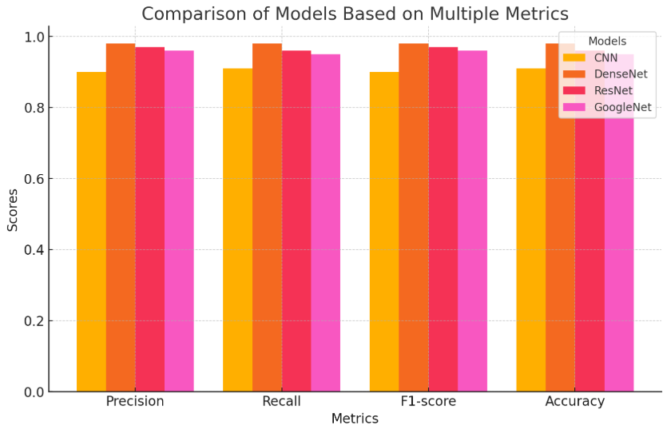
The table 5.1, 5.2, 5.3 and 5.4 depicts the model’s information on the accuracy of the CNN, ResNet50, GoogleNet, and DenseNet on normal and AMD-affected OCT images. DenseNet was found to outperform the other models, obtaining the highest accuracy, and demonstrating its ability to extract fine features. ResNet50 and GoogleNet also performed well using deep residual and inception-based architecture.

Fig 5.1. Model Comparison graph
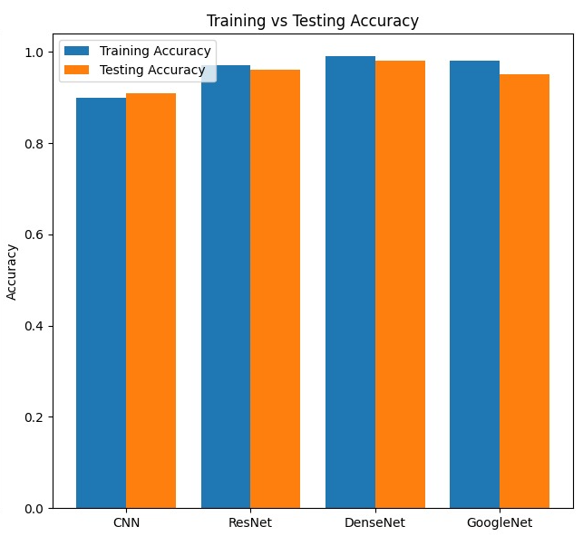
A comparison plot fig 5.1 of models plots the performance of a subset of deep learning models employed for OCT image classification in graphical format. The plot will facilitate the comparison and assessment of performance between the various models in terms of the model performance metrics like accuracy, precision, recall, and F1-score.

Fig 5.2. Model Training and Testing Accuracy
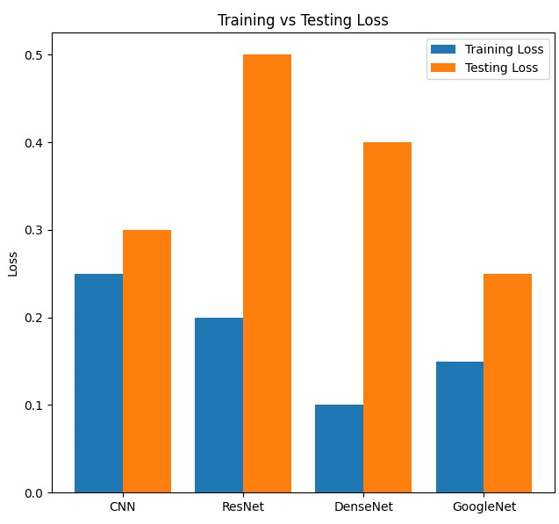

Fig 5.3. Model Training and Testing loss
In the present work, several deep models such as ResNet50, GoogleNet, DenseNet, and a personalized CNN were trained on binary as well as multiclass datasets to classify OCT images into AMD, DME, CNV, and Normal classes. The above graph that is fig 5.1, 5.2 and 5.3 shows the comparison differences in accuracies obtained by these models in distinguishing between retinal images of normal and diseased conditions.
5.3 Analysis of results
An analysis of the performance of a deep learning model in multiclass OCT image classification provides valuable insight into the model's performance in discriminating among Normal, AMD, DME, and CNV conditions. The study evaluates the contributing factors associated with high classification performance, including data distribution, model architecture, and feature extraction methodology.
- Effectiveness of Feature Extraction: Deep learning algorithms such as ResNet50, GoogleNet, DenseNet, and a custom CNN were trained to automatically learn hierarchical features from OCT images. These models have used the convolutional layers to learn the variations, changes in there texture, and spatial relationships of the retinal structures instead of classic machine learning models based around different features.
The experimental findings show that DenseNet performed better than other models and attained a staggering 98% accuracy in multiclass classification.The reason behind its improved performance is its highly connected layers, which allows efficient propagation and reuse of features, leading to better gradient flow and reduced redundancy in feature learning.
Both GoogleNet and ResNet50 were very accurate. They were able to do this by using the complex designs with residual network connections and inception modules, which improve feature extraction but add on the more work to the computer.The pre-trained CNN, though good at extracting meaningful patterns, did slightly worse because of its shallow depth and fewer parameters compared to pre-trained models.These results confirm that models based on deep learning are optimal for OCT image classification because they are able to learn and remember complex features automatically without any human interference.
- Impact of Data Distribution: The research also investigates how data distribution affects model performance. The data set had imbalanced classes, where some disease categories had much fewer samples than others. This imbalance caused difficulties for the models, especially for the custom CNN, which showed misclassifications in the minority classes.
Despite the imbalanced dataset, DenseNet and ResNet50 performed well in classifying all four disease categories. The models were robust due to their deep architecture, which allows for better feature generalization. In addition, data augmentation strategies such as flipping, rotation, and contrast variations were applied to enhance classification performance by artificially increasing the number of training samples for some of the underrepresented classes.
These results emphasize the need for balanced training strategies and data preprocessing to ensure that deep learning models generalize well across all disease types.
The comparative study proves DenseNet to be the best-performing model for multiclass classification of OCT images, followed by ResNet50 and GoogleNet.
To analyze the performance of all the models, the ROC curves (AUC), accuracy, loss, test and training accuracies of all the deep learning models is shown in the below images.
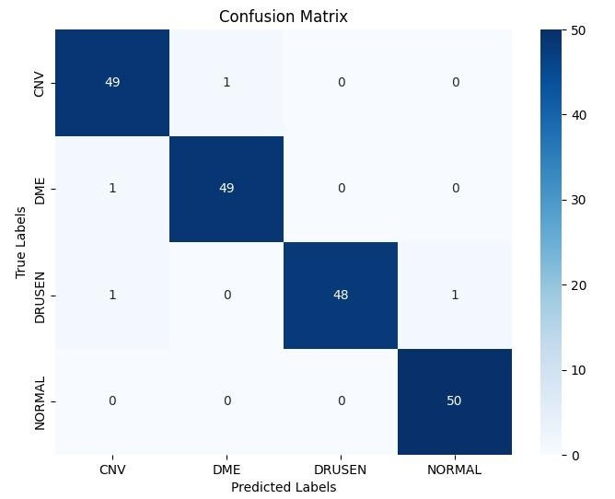

Fig 5.4. Confusion matrix
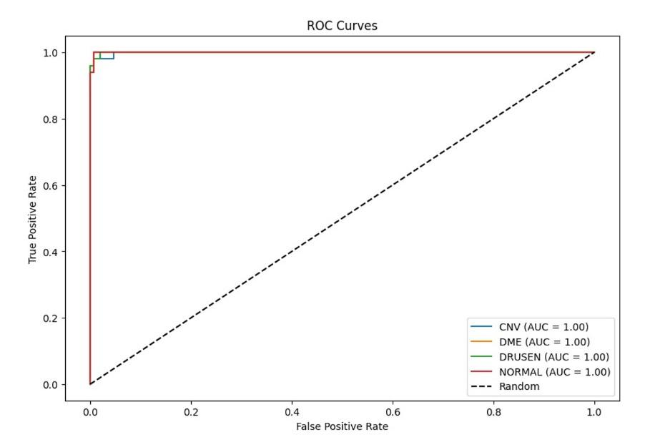

Fig 5.5. Roc Curve
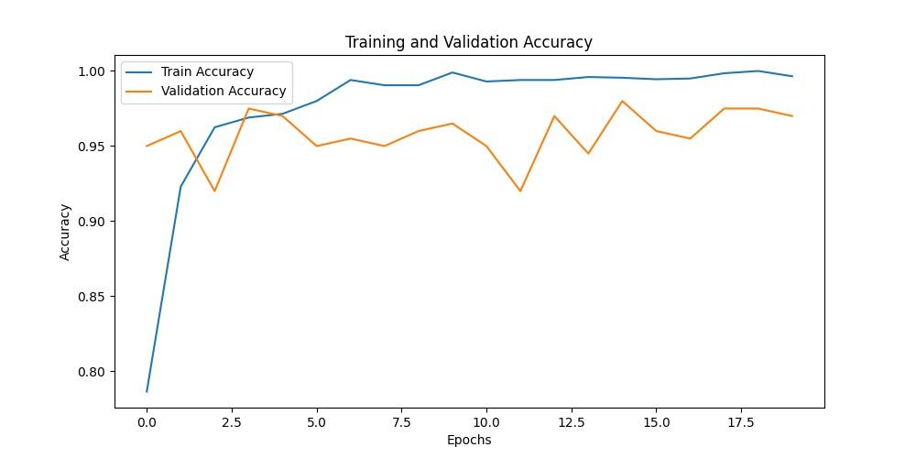

Fig 5.6. Accuracy Curve
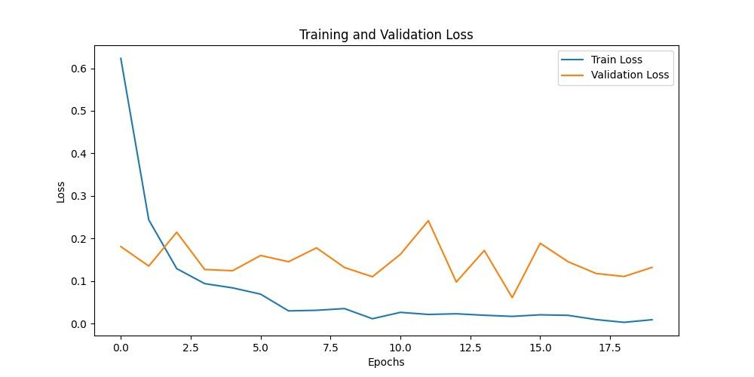

Fig 5.7. Loss Curve
To check how well the deep learning models are performing, we recovered a number of graphs such as ROC curves, loss-accuracy curves, and confusion matrices. The ROC curve gives the trade-off between sensitivity and the false positive rates, and the AUC score depicts how good and trained the model can classify between classes. DenseNet performed best in classification, as seen from its highest AUC, followed by ResNet50 and GoogleNet. The custom CNN model recorded lower AUC scores, indicating that it was not able to differentiate the classes well. Higher AUC values indicate the model is more confident in its predictions, which is of utmost importance in medical imaging.
The loss and accuracy curves illustrate how the models learn. Both DenseNet and ResNet50 improved smoothly with high accuracy, while GoogleNet was notably behind. The custom CNN model fluctuated in its accuracy, which indicates some learning problems. An overall decrease in loss over time indicates that the training process was successful, and DenseNet achieved the lowest loss values, thus improving generalization.
To enable the deployment of our deep learning-based OCT image classification system, we designed a working web application that simplifies the use of trained models for users. The web application bridges the gap between complex AI algorithms and effective, real-time deployment using a well-established and effective technology stack.
The technology stack used In the web application development is the following:
- Frontend Development: HTML5 was employed to organize the web pages, creating the skeleton of the user interface. CSS was used to style the website in a manner that made it visually appealing and user-friendly. JavaScript provided dynamic functionality to the site, enabling successful interaction and real-time feedback on user uploading of OCT images and display of classification results.
- Backend Development: Flask (Python) has been employed as backend technology. Flask is light but robust, ideally suited to act as the interface between frontend and our deep learning models. It receives the input image data, processes the data, and sends the predictions back to frontend. Flask manages the image uploading, start the model inference process, and stream the results in real-time.
- AI and Image Uploading: TensorFlow and PyTorch were utilized in the organizing and deployment of the deep learning models like DenseNet, ResNet50, GoogleNet, and the custom CNN model. TorchVision was used for model utilities and pre-processing, which enabled image transformation and loading pre-trained models. Pillow (Python Imaging Library) enabled processing and pre-processing image files uploaded through the interface.
- Integration and Workflow: The frontend communicates with the Flask backend directly, uploading OCT images as inputs through a simple upload process. When it is given an image, the backend processes the image with Pillow and TorchVision, feeds the image into the selected deep learning model, and receives the classification output (Normal / AMD / CNV / DME).
This cloud-based deployment brings AI-powered OCT image classification capability into the form of simple-to-use real-time software. It provides high-performance deep learning models to users to apply without knowing the nitty-gritty of model training or infrastructure deployment. Below are some of the screenshots attached with the fully functionally outputs.
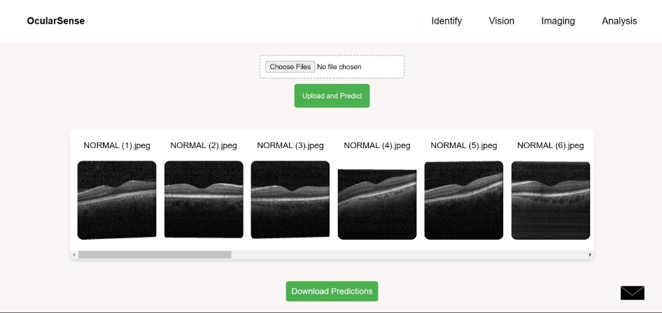

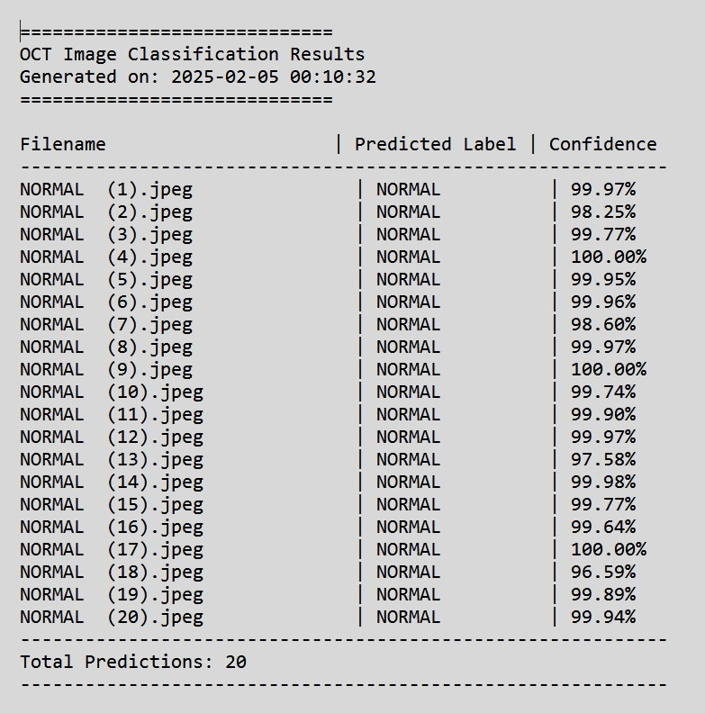
Fig 5.8. Web-application Desktop version

Fig 5.9. Web-application Output image
5.4 Suggestions and Recommendations
Based on the findings of this study, several recommendations can improve future OCT image classification efforts:
- Deep Feature Extraction: Instead of just using GLCM and first-order statistics, the addition of deep feature extraction or wavelet transforms can help to capture more detail in OCT images, potentially helping us to classify them better
- Enhanced Data Augmentation: Using methods like image stretching, contrast adjustment, and addition of noise can enhance the diversity in the dataset and make models better equipped to handle real-world variations in OCT scans.
- Attention Mechanisms: Incorporating attention layers into deep learning models can assist in concentrating on the relevant parts of the image, improve decision-making and model interpretability.
- Ensemble Learning: Using weighted voting or stacking to combine multiple models (like DenseNet ResNet50, and GoogleNet) can take advantage of their unique strengths to boost classification reliability.
- Computational Efficiency: Improving deep learning models with methods such as knowledge distillation can lead to quick predictions that are accurate. This makes the models even more better suited for medical applications that need a real-time result.
- Fine-Tuning of Models: Altering parameters such as learning rates, optimization functions, and dropout percentage can enhance the performance of the model. This allows the model to accommodate various datasets.
- Clinical System Integration: Integrated systems with hospital databases and diagnostic equipment are able to automatically sort OCT images in clinical settings.
- Future Research: Developing the self-supervised learning or transformer-style designs such as Vision Transformers (ViTs) might make the models more stronger and also able to handle various retinal datasets.
Incorporating these suggestions can not only enhance the classification accuracy for OCT images but also strengthen model generalizability, making it more applicable for real-world medical imaging scenarios.

CHAPTER 6
CONCLUSIONS AND FUTURE WORK
6.1 Summary
In this project, we are dealing with the automatic classification of OCT images to separate healthy eyes from Age-Related Macular Degeneration (AMD)-affected eyes by employing deep learning models. For obtaining precise and efficient classification, we used sophisticated Convolutional Neural Networks (CNNs) such as ResNet50, GoogleNet, DenseNet, and our own custom CNN architectures (CNN5, CNN7, and CNN9).
The training and testing data used comprised 4,200 OCT images, split into different ratios of training-to-testing (50:50, 40:60, and 60:40) to test model performance across different data distributions. Of the models, DenseNet and ResNet50 performed best in terms of accuracy, laying strong emphasis on their suitability for processing intricate medical image classification tasks. To ensure practicality for this research, we created a web-based application that would allow users to upload OCT images and get instant classification outcomes.
The frontend was implemented utilizing HTML, CSS, and JavaScript, for a user-friendly and intuitive interface. The backend was implemented using Flask (Python) to provide smooth interaction between the web interface and the deep learning model. For AI model deployment and image processing, we have taken the use of TensorFlow, PyTorch, TorchVision, and Pillow to enable fast OCT image processing.
The web application gives us the critical features like real-time classification of images, immediate display of results, options for model selection, and rapid processing, rendering it usable by medical professionals as well as researchers. The application of the deep learning in medical imaging and ophthalmology has great promise in helping doctors with early retinal detection, ultimately leading to better patient outcomes.

6.2 Conclusions
The significance of the deep learning in the field of medical imaging, specifically when classifying OCT images into four disease stages: normal, AMD, CNV, and DME, is the focus of this study. Experimental results demonstrate that deep learning networks can detect diseases successfully by observing the structural differences in retinal layers. DenseNet and ResNet50 networks are very much efficient and reliable in running the deep learning models, and each produced excellent accuracy, making them suitable for use in a clinical diagnostic setting.
One of the most important findings from this research is the effect of data preprocessing and balanced dataset distribution on model performance. With effective OCT scans of high quality and effective augmentation techniques, model performance in generalizing across various groups of patients can be significantly improved. Additionally, using sophisticated optimization methods such as learning rate scheduling and different parameter or the hyperparameter tuning can further improve classification accuracy.
Overall, this work uses deep learning in a stand of strength in ophthalmology and gives the way for better accuracies, automated, and scaleable methods for retinal disease classification.
6.3 Future Enhancements
Looking ahead, advancements in technology promise to further enhance the classification of eye diseases, particularly beyond Optical Coherence Tomography (OCT). Some promising areas of development include:
    - Improved Deep Learning Architectures: Implementing architectures such as Vision Transformers (ViTs), hybrid CNN-RNN models can improve classification accuracy by learning both spatial and sequential relationships of images of OCT.
    - Attention Mechanisms for Explainability: Incorporating attention-based models allows emphasis to be placed on important areas in OCT scans, improving interpretability and supporting ophthalmologists in clinical decision-making.

REFERENCES

- Dong, Y., Zhang, Q., Qiao, Z., Yang, J.-J.: Classification of cataract fundus image based on deep learning. In: 2017 IEEE International Conference on Imaging Systems and Techniques (IST), pp. 1–5. IEEE (2017). https://doi.org/10.1109/IST.2017.8261463
- Raghu Raj, P., Gurudatha Pai, K., Shylaja, S.S.: Algorithmic approach for prediction and early detection of diseases using retinal images. In: Computer Graphics, Imaging and Visualisation (CGIV 2007), pp. 501–505. IEEE (2007). https://doi.org/10.1109/CGIV.2007.16
- Kadry, S., Rajinikanth, V., Crespo, R.G., Verdú, E.: Automated detection of age-related macular degeneration using a pre-trained deep-learning scheme. J. Supercomput. 78, 7321–7340 (2022). https://doi.org/10.1007/s11227-021-04181-w
- Wong, W.L., Su, X., Li, X., Cheung, C.M.G., Klein, R., Cheng, C.Y., Wong, T.Y.: Global prevalence of age-related macular degeneration and disease burden projection for 2020 and 2040: a systematic review and meta-analysis. Lancet Glob. Health 2(2), e106–e116 (2014)
- Zhang, Y., Wang, L., Wu, Z., Zeng, J., Chen, Y., Tian, R., Zhang, G.: Development of an automated screening system for retinopathy of prematurity using a deep neural network for wide-angle retinal images. IEEE Access 6, 1–1 (2018). https://doi.org/10.1109/ACCESS.2018.2881042
- Latha, S., Dhanalakshmi, S.: Enhancing machine learning aptitude using significant cluster identification for augmented image refining. Int. J. Pattern Recognit. Artif. Intell. 34, 1–19 (2019)
- Diederik Kingma and Jimmy Ba, "Adam: A Method for Stochastic Optimization", International Conference on Learning Representations, 2014.
- A. Albarrak, F. Coenen, and Y. Zheng, ‘‘Age-related macular degeneration identification in volumetric optical coherence tomography using decomposition and local feature extraction,’’ in Proc. Int. Conf. Med. Image, Understand. Anal., 2013, pp. 59–64.
- M. D. Rouzi, B. Moshiri, M. Khoshnevisan, M. A. Akhaee, F. Jaryani, S. S. Nasab, and M. Lee, ‘‘Breast cancer detection with an ensemble of deep learning networks using a consensus-adaptive weighting method,’’ J. Imag., vol. 9, no. 11, p. 247, Nov. 2023.
- D. Romo-Bucheli, U. S. Erfurth, and H. Bogunovic, ‘‘End-to-end deep learning model for predicting treatment requirements in neovascular AMD from longitudinal retinal OCT imaging,’’ IEEE J. Biomed. Health Informat., vol. 24, no. 12, pp. 3456–3465, Dec. 2020.
- P. Huang, P. He, S. Tian, M. Ma, P. Feng, H. Xiao, F. Mercaldo, A. Santone, and J. Qin, ‘‘A ViT-AMC network with adaptive model fusion and multiobjective optimization for interpretable laryngeal tumor grading from histopathological images,’’ IEEE Trans. Med. Imag., vol. 42, no. 1, pp. 15–28, Jan. 2023
- R.R. Selvaraju, M. Cogswell, A. Das, R. Vedantam, D. Parikh, D. Batra, Grad-cam: Visual explanations from deep networks via gradient-based localization, Proceedings of the IEEE International Conference on Computer Vision (2017) 618–626.
- Y. Tian, H. Zeng, J. Hou, J. Chen, and K.-K. Ma, ‘‘Light field image quality assessment via the light field coherence,’’ IEEE Trans. Image Process., vol. 29, pp. 7945–7956, 2020.
- R. T. Yanagihara, C. S. Lee, D. S. W. Ting, and A. Y. Lee, ‘‘Methodological challenges of deep learning in optical coherence tomography for retinal diseases: A review,’’ Transl. Vis. Sci. Technol., vol. 9, no. 2, p. 11, Feb. 2020.
- A. M. Alqudah, ‘‘AOCT-NET: A convolutional network automated classification of multiclass retinal diseases using spectral-domain optical coherence tomography images,’’ Med. Biol. Eng. Comput., vol. 58, no. 1, pp. 41–53, Jan. 2020.

